CHAPTER III
RESEARCH METHODOLOGY

Research Type
This study is categorized as an explanatory study with a quantitative approach. An explanatory study systematically explores the cause of a phenomenon when there is limited information known. This research seeks to understand and describe why a related event/phenomenon/behavior occurs (Mertler, 2018). For example, an explanatory study can be used to answer the strongest predictor of e-service quality and its effect on user satisfaction.

Research Framework
Based on the background and literature studies conducted, this study adopted the conceptual model by Rita et al. (2019) and Kim (2015) to measure the relationship between the dimensions that influence e-service quality (website design, security/privacy, and fulfillment). Furthermore, this study measured the effect of a sense of belonging on user satisfaction with the measurement scale adopted based on Sharabati et al. (2022) and Hung et al. (2019).
The intention to use construct was adopted based on research by Hossain & Kim (2018). The variables' indicators were adjusted to Discord's online community services application based on the website performance index measurement. Further explanation of the conceptual model, inner and outer models adopted in this study will be explained in section 3.2.1 below.

Conceptual Model
This study's inner or structural model consists of overall e-service quality dimensions (website design, security/privacy, and fulfillment), sense of belonging, user satisfaction, and intention to use. The proposed inner model used in this study can be seen in Figure 3.1 below.
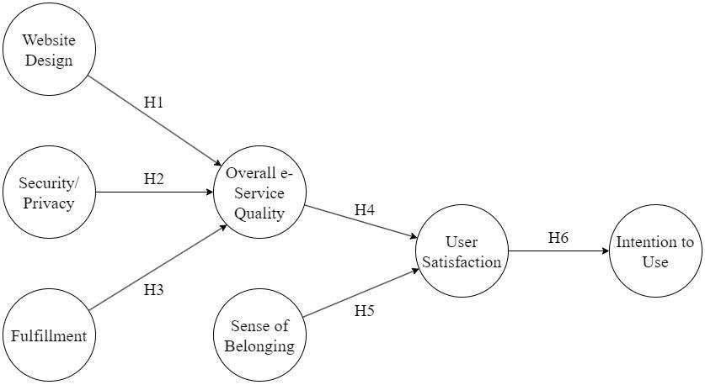
Figure 3.1 Proposed Inner Model
The proposed outer model or measurement model presents the measured constructs, as shown in Figure 3.2 below.
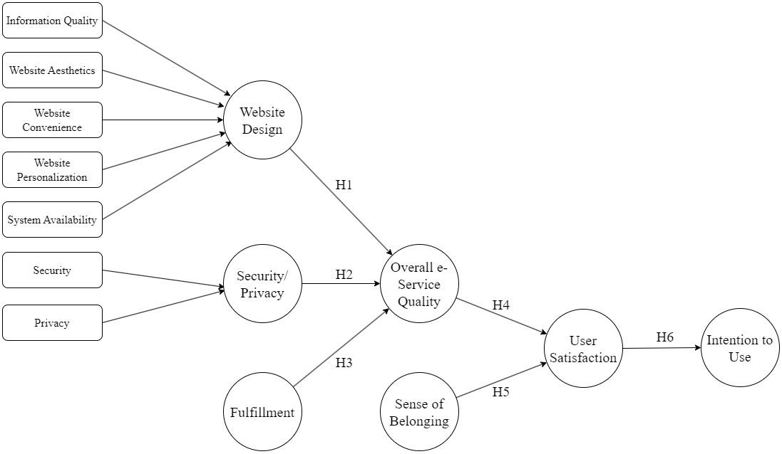
Figure 3.2 Proposed Outer Model
In this research’s proposed outer model, e-service quality dimensions (website design and security/privacy) were second-order constructs operationalized as reflective-formative types. Each e-service quality attribute was reflective, and the e-service quality dimensions were formative. Several adjustments to the measurement model were made to the proposed research model due to differences in the industrial segment of the research object in this study. The e-service quality model from Blut (2016) was simplified based on the prior related studies of measuring e-service quality focused on website performance (Chuang et al., 2016; Dickinger & Stangl, 2013; Wu et al., 2015; Yum & Yoo, 2023).
Since it suggested that fulfillment is a crucial factor in assessing e-service quality (Kaya et al., 2019; Kim, 2015; Rita et al., 2019), the indicators to measure fulfillment were instead adopted from Kim (2015), which aimed to apply the e-service quality dimension to the social media services. However, the fulfillment construct in Kim (2015) is operationalized as a first-order dimension, unlike Rita et al. (2019). Therefore, it caused an adjustment in this construct from a higher-order construct to a lower-order construct.

Research Hypotheses
The hypotheses proposed in this study are as follows:
H1: Website Design positively affects Overall e-Service Quality.
H2: Security/Privacy positively affects Overall e-Service Quality.
H3: Fulfillment positively affects Overall e-Service Quality.
H4: Overall e-Service Quality positively affects User Satisfaction.
H5: Sense of Belonging positively affects User Satisfaction.
H6: User Satisfaction positively affects Intention to Use.

Research Population and Sample

Population
The population representing this study's target audience comprises 5500 individuals exclusively from the ‘Perkumpulan Orang Santai’ Discord community server. This community consists of members from across Indonesia, serving as a representative sample of Discord users in Indonesia with a diverse and extensive cultural background. The reasoning behind selecting this community as a research object is in accordance with familiarity and data accessibility. As a part of a community member, the researcher possessed a comprehensive understanding of its culture, as well as the ease of obtaining relevant data.

Sample
Statistically, the larger the sample size, the better results can be expected. This study used a margin of error of 5%, which is the value most often chosen as MOE (Etikan & Babatope, 2019). Using Slovin’s formula below, the total sample of this study can be concluded as 372.8, rounded up to 373 individuals.
$$n= \frac{N}{1+N{(e)}^{2}}$$
Equation 4. Slovin’s Equation
In this equation, n refers to the sample size, N refers to the population size (375 individuals), and e refers to the margin of error used in this study (5%).

Characteristics of Respondents
Respondents from this study were divided based on age (13-17 years, 18-22 years, 23-27 years, 28 years/above), gender (Men, Women, prefer not to answer), last education (Highschool/below, Associate Degree (D1/D2/D3), Applied Bachelor/Bachelor (D4/S1), Master’s degree/above), Salary (Rp 0.00 until up to Rp 6.000.000.00), years of being a Discord application user (0-6 months, 7-12 months, more than one year), and Discord discovery source (Friends, Family, College/School, Social Media, and Broadcast/Print Media).

Data Collection

Data Type
The type of data collection used in this study is primary data. The data collected directly is called primary data, which has not been altered and is more reliable and objective (Kabbir, 2016). Therefore, its validity is superior to secondary data.

Data Collection Model
The data collection method in this study was using a survey or questionnaire made in Google Forms. The survey method, generally using a questionnaire, is one of the most popular methods in the social sciences (Young, 2015). The popularity of these methods in small-scale intercultural research is linked to perceived ease of use and the access they can provide to large amounts of data that even the most inexperienced researcher can analyze.
The type of questions that were used in this study were closed-ended. Closed-ended questions are questions with some known information/variables and only have one correct answer that can be obtained due to the relationship between these variables. Thus, the answer to this type of question is clear and solved by specific rules/formulas (Agustianingsih & Mahmudi, 2019).
The sampling technique used in this study was simple random sampling. This sampling technique selects sample members randomly and purely by chance. Therefore, the quality of the sample is not affected because each member has an equal chance of being selected for the sample. The simple random sampling technique was chosen in this study because this type of sampling is best for very homogeneous populations (Bhardwaj, 2019). This study distributed the questionnaire link to a specific Discord server named ‘Perkumpulan Orang Santai’.

Measurement Scale
The measurement scale in this study uses a Likert Scale. As a psychometric tool, this scale includes a set of research study hypothesis statements. Respondents in this study were asked to state their agreement to each statement ranging from strongly agree to strongly disagree. The defined five-point Likert Scale can be seen in Table 2 below.

Table 2. Likert Scale
No | Answer Choices | Scale
1 | Strongly Agree (SA) | 5
2 | Agree (A) | 4
3 | Neutral (N) | 3
4 | Disagree (D) | 2
5 | Strongly Disagree (SD) | 1

Construct Operational Definitions
The following is a description of the variables and operational definitions of the variables used in this study.

Constructs
The exogenous and endogenous constructs adopted in this study are as follows:
- Exogenous Constructs
The exogenous constructs in this study are website design, security/privacy, fulfillment, and sense of belonging.
- Endogenous Constructs
The endogenous constructs in this study are overall e-service quality, user satisfaction, and intention to use.

Construct Operational Definitions
The following table presents the constructs, attributes, and references used in this study.
Table 3. Adopted Constructs, Attributes, and the References
Constructs |  | Attributes | References
Website Design | Information Quality | IQ1. The information provided on the Discord desktop application is sufficient to support my tasks and interact with my community.  IQ2. Discord adequately meets my information needs to interact with community members (notifications, profile status, date, etc.).  IQ3. The information provided on Discord is effective (features description, maximum size/type of file, the maximum length of text characters, new updates explanation, etc.). | (Rita et al., 2019)
 | Website Aesthetics | WA1. Discord's interface is visually pleasing (palette color selection, app layout, text/image size, etc.).  WA2. Discord's interface is visually appealing (it has unique app design characteristics that can distinguish it from other apps). | (Rita et al., 2019)
 | Website Convenience | WC1. Discord displays visually pleasing, easy-to-read content.  WC2. The text on the Discord is easy to read.  WC3. Labels on the Discord (notifications, inbox, upload files, etc.) are easy to understand. | (Rita et al., 2019)
 | Website Personalization | WP1. Discord provides features that allow me to personalize my experience using the desktop application (customized profile, notification preferences, organizing channel, etc.).  WP2. Discord has interactive features to support me in interacting with community members (member roles, text/voice channels, live streams, etc).  WP3. I can interact and utilize the interactive features in the Discord desktop application to get information tailored to my needs (message search, filters, mutual friend/server, etc.). | (Rita et al., 2019)
 | System Availability | SA1. Discord application offers very little waiting time between my actions and the app’s response (responsive).  SA2. Discord desktop application loads quickly when I run it for the first time. | (Rita et al., 2019)
Security/Privacy | Security | SC1. I feel safe when using Discord to interact with community members.  SC2. Discord has adequate security features.  SC3. Discord provides protection for my personal data. | (Rita et al., 2019)
 | Privacy | PR1. I trust Discord to keep my personal data safe.  PR2. I trust Discord will respect and not misuse my personal data.  PR3. Discord protects my privacy regarding interaction and social activity data generated while using the application. | (Dalbehera, 2020; Rita et al., 2019)
Fulfillment |  | FU1. Discord offers features that have been very helpful in answering my questions (Support Center, Frequently Asked Questions, Community Blog, etc.).  FU2. Getting the information I want to meet my needs in interacting with the community is not difficult.  FU3. Discord lived up to my expectations by providing excellent information and assistance in a very short timeframe. | (Kim, 2015)
Overall e-Service Quality |  | OSQ1. Overall, I am very comfortable interacting with the community within Discord.  OSQ2. The overall quality of the service Discord provides for interacting with the community is excellent.  OSQ3. My overall feeling for the Discord application service is delighted. | (Rita et al., 2019)
Sense of Belonging |  | SB1. I am proud to be a member of my Discord community.  SB2. I feel happy to be a part of my Discord community.  SB3. I feel a strong attachment to my Discord community. | (Sharabati et al., 2022; Wang et al., 2019)
User Satisfaction |  | US1. I am satisfied with the Discord app.  US2. Discord service is getting closer to the ideal online community space.  US3. Discord has always met my needs in the community. | (Rita et al., 2019)
Intention to Use |  | IU1. I am considering using Discord regularly.  IU2. I plan to use the Discord service to do community activities.  IU3. In the future, I will use Discord services whenever I need to. | (Hossain & Kim, 2018; Nguyen et al., 2022; Udo et al., 2010)

Statistical Analysis Approach
This research adopted higher-order constructs for two e-service quality dimensions (Website Design and Security/Privacy). Higher-order constructs were adopted because they facilitate conceptualizing a construct on a more abstract higher-level dimension and its more specific lower-order subdimensions, allowing researchers to capture the complex relationships between constructs (Sarstedt et al., 2019). The relationship between first-order constructs and their respective indicators was represented as reflective. Meanwhile, the relationship between first-order constructs to their second-order constructs was described as formative. Therefore, the multi-collinearity, significance, and the sign of weights test were also measured (Rita et al., 2019).
The evaluation criteria in the embedded-two-stage approach are separated into two main stages. In the first stage, there are two assessments to conduct. The first step is validating the reflective and formative measurement model. After these constructs are validated, the structural model is analyzed to test the collinearity, significance, and relevance of the path coefficients.

Validating the Reflective Measurement Model
In the first step of the embedded two-stage approach, convergent validity, reliability, and discriminant validity were assessed. Convergent validity was assessed using factor loading, Composite Reliability (CR), and Average Variance Extracted (AVE). It is suggested as ideal if every indicator’s factor loading is more than 0.5 and ideally 0.7 or higher, composite reliability exceeds 0.70, and AVE exceeds 0.50 (Gefen et al., 2000; Hair et al., 2010; Kline et al., 2012). Cronbach’s alpha was also evaluated to test the consistency of the instrument’s reliability. The recommended Cronbach’s alpha value is 0.7 or higher, but 0.6 or higher is also acceptable (Hair et al., 2011).
Discriminant validity ensures that a construct’s indicator is unique and highly correlated to its respective construct. In this study, discriminant validity was assessed using the cross-loadings and Fornell-Larcker criterion. Cross-loadings were assessed based on the single construct indicator, which should have a higher loading on its own construct than on other constructs (Chin, 1998). Fornell-Larcker criterion was evaluated based on the square root of each latent construct’s AVE, which should be higher than the squared correlations with other latent constructs

Validating the Formative Measurement Model
The second assessment validates the formative constructs, which used the latent construct scores were used as indicators for the second-order constructs. The multi-collinearity, weights, and significance of formative indicators were assessed.
Multi-collinearity tests using the variance inflation factor (VIF) were conducted to determine if two or more indicators in a formative measurement model are too highly correlated. Hair et al. (2021) stated that a VIF value greater than five or above indicates a collinearity problem.
Bootstrapping method using the bias-corrected and accelerated (BCa) confidence interval method can be used to examine the statistical significance of indicator weights if they are skewed (Hair et al., 2019). Otherwise, the percentile method should be used. The t-value and p-value generated from bootstrapping were used to evaluate indicator weights’ statistical significance. The t-value should be above 1.96 (two-tailed test) and the p-value below 0.05 for a 95% confidence interval (Hair et al., 2019, 2021a).

Structural Model Evaluation
Four criteria to evaluate the predictive capability of the model (coefficient of determination (R²), cross-validated redundancy (Q²), effect size (f²), and path coefficients) were used to test the structural model. The recommendations to evaluate the structural model are as follows.
1) General recommendation of R² values 0.75, 0.50, and 0.25 in marketing research can be considered substantial, moderate, and weak (Hair et al., 2011). In consumer behavior research, R² values of 0.20 are considered high, and R² values of 0.75 are perceived as high in success driver studies. The coefficient of determination were tested using both of these guidelines.
2) Q² values should be more than 0 for a specific endogenous construct, suggesting that the path model has adequate predictive relevance to certain constructs (Sarstedt et al., 2017).
3) Exogenous latent construct with ƒ2 values of 0.02, 0.15, and 0.35 represent small, medium, and large effects (Cohen, 1988). Effect size values smaller than 0.02 suggest that there is no effect.
4) Path coefficients are evaluated regarding the structural paths between the constructs based on the hypothesis made in this research. This evaluation aims to determine the significance and relevance of path coefficients. The bootstrapping method in SmartPLS 4 can be used to evaluate both.

